Segment trees

Need of segment trees
Let us take an example of returning and updating the sum of the subarray a[i….j] of an array of size n.

Example
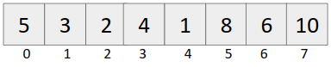
Query: Output the sum from i=1 to i=5.
Update: Update the element at i^{th} index. Example: put a[4] = 13.

Approach 1
For query: Iterate from i=1 to i=5 and calculate the sum.
Time complexity: O(n)

For update: Update the ith index, simply put a[i] = updated_element

Query | Update
O(n) | O(1)

Approach 2 (Prefix Sum Approach)
Build the prefix sum array
Given array:


Prefix sum array:
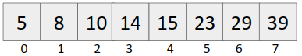

For query: Output sum from i to j (0 <= i <= j < n) (say i=1 to i=5)
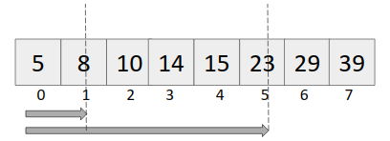

Sum[i....j] = pref[j]-pref[i-1] {if i!=0}
pref[j] {if i = 0}

Time complexity: O(1)

For update: Put a[i] = updated_value
To update in the prefix array, we need to change all pref[i₁] {i₁ >= i}

Example: Update the 4th indexed element to 13.

Original Array becomes:
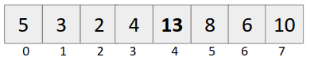

Prefix sum array becomes:
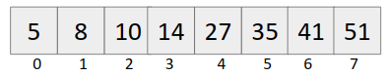

Time complexity: O(n)

Time complexity of this approach
Query | Update
O(1) | O(n)

If we want both the operations to be in reasonable time, we use segment trees.

Time Complexity comparison table

Approach | Query | Update
Approach 1 | O(n) | O(1)
Approach 2 | O(1) | O(n)
Segment tree | O(log(n)) | O(log(n))

Requirement of log(n) time complexity: Many a times, number of queries and number of updates are of the order of 10⁵-10⁶, we will get tle if we use Approach 1 or Approach 2.

Segment tree construction
Given array:


Power of number 2 in programming
- Binary Representation of numbers - All operations be it sum / subtraction/ product, all are accomplished in O(1).
- Division of array (Divide and conquer)

We can divide the above array as
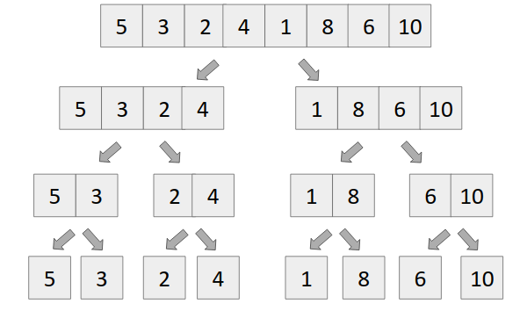

Number of nodes = n + n/2 + n/4 + . . . . + 2 + 1 , which is geometric progression
Let number of terms in the above G.P. be x, which denotes the height of the segment tree.

We know,
ar^{x-1} = n
putting a = 1, r = 2, we get
(2)^{x-1} = n
log₂(2^{x-1}) = log₂n
x = 1 + log₂n

Number of nodes = 1 + 2 + 4 + . . . . + n/4 + n/2 + n.
= 1((2)^{1+log(n)} - 1) / 2-1
= 2.2^{log(n)}-1
= 2n-1

For safety, we make segment tree of size 4*n.

Structure of segment tree
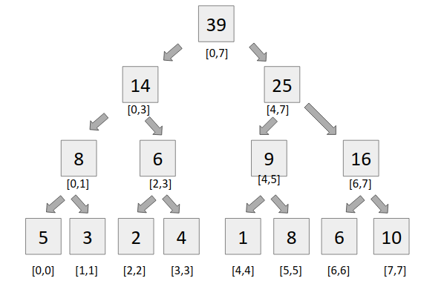

Building a segment tree
It is very simple to build a segment tree, we use divide and conquer approach to build the segment tree.

Code:
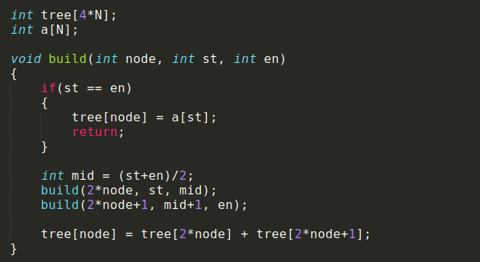

Query
For query, we see two types of segments
- Complete overlapping segments - When our st Partial overlapping segments and en lies completely in the range [l,r], it is called complete overlapping segment.
- Partial overlapping segments - When our st and en does not lie completely in the range [l,r], it is called partial overlapping segment.

Code:
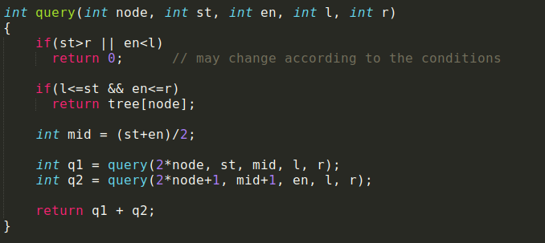

Update
Updating an element in the segment tree is very similar to binary search.
We find out mid, and compare our index with mid and two conditions arise
- Idx <= mid, then we recursively call the left child of the tree’s node.
- Idx > mid, then we recursively call the right child of the tree’s node.

Code:
